ANS 1----

CREATE TABLE department (
dept_id INT PRIMARY KEY,
dept_name VARCHAR(30)
);

CREATE TABLE employee (
emp_id INT PRIMARY KEY,
emp_name VARCHAR(50),
salary NUMERIC(10,2),
dept_id INT REFERENCES department(dept_id)
);

INSERT INTO department VALUES
(1, 'IT'),
(2, 'Sales'),
(3, 'HR');

INSERT INTO employee VALUES
(101, 'Aman', 90000, 1),
(102, 'Neha', 70000, 1),
(103, 'Raj', 50000, 1),
(104, 'Priya', 80000, 2),
(105, 'Karan', 60000, 2),
(106, 'Riya', 40000, 2),
(107, 'Mohit', 75000, 3),
(108, 'Simran', 55000, 3);

SELECT
d.dept_name,
e.emp_name,
e.salary
FROM employee e
JOIN department d
ON e.dept_id=d.dept_id
WHERE e.dept_id IN(
SELECT dept_id
FROM employee
GROUP BY dept_id
HAVING COUNT(*)>=3
)
AND e.salary>(
SELECT AVG(e2.salary)
FROM employee e2
WHERE e2.dept_id=e.dept_id
);

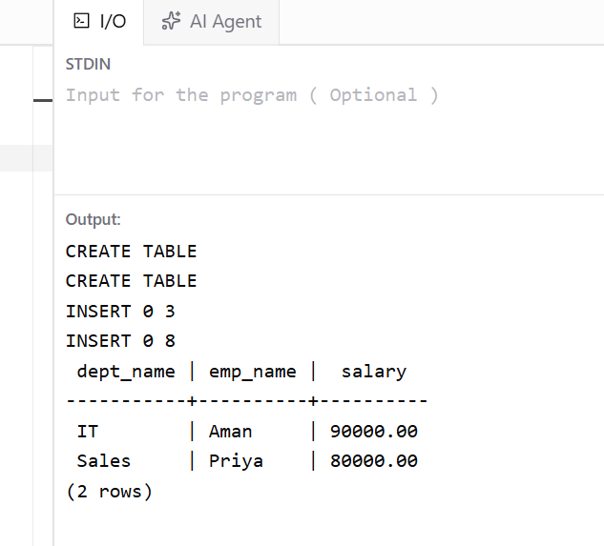

ANS 2----

CREATE TABLE bank_customer (
customer_id INT PRIMARY KEY,
customer_name VARCHAR(50),
balance NUMERIC(10,2)
);

CREATE TABLE customer_audit (
audit_id SERIAL PRIMARY KEY,
customer_id INT,
customer_name VARCHAR(50),
action VARCHAR(20),
action_time TIMESTAMP
);

INSERT INTO bank_customer VALUES
(1, 'Rahul', 50000),
(2, 'Neha', 75000);

create or replace trigger abc
(
customer_id primary key,
customer_name,

)
after insert or delete



